For Lease

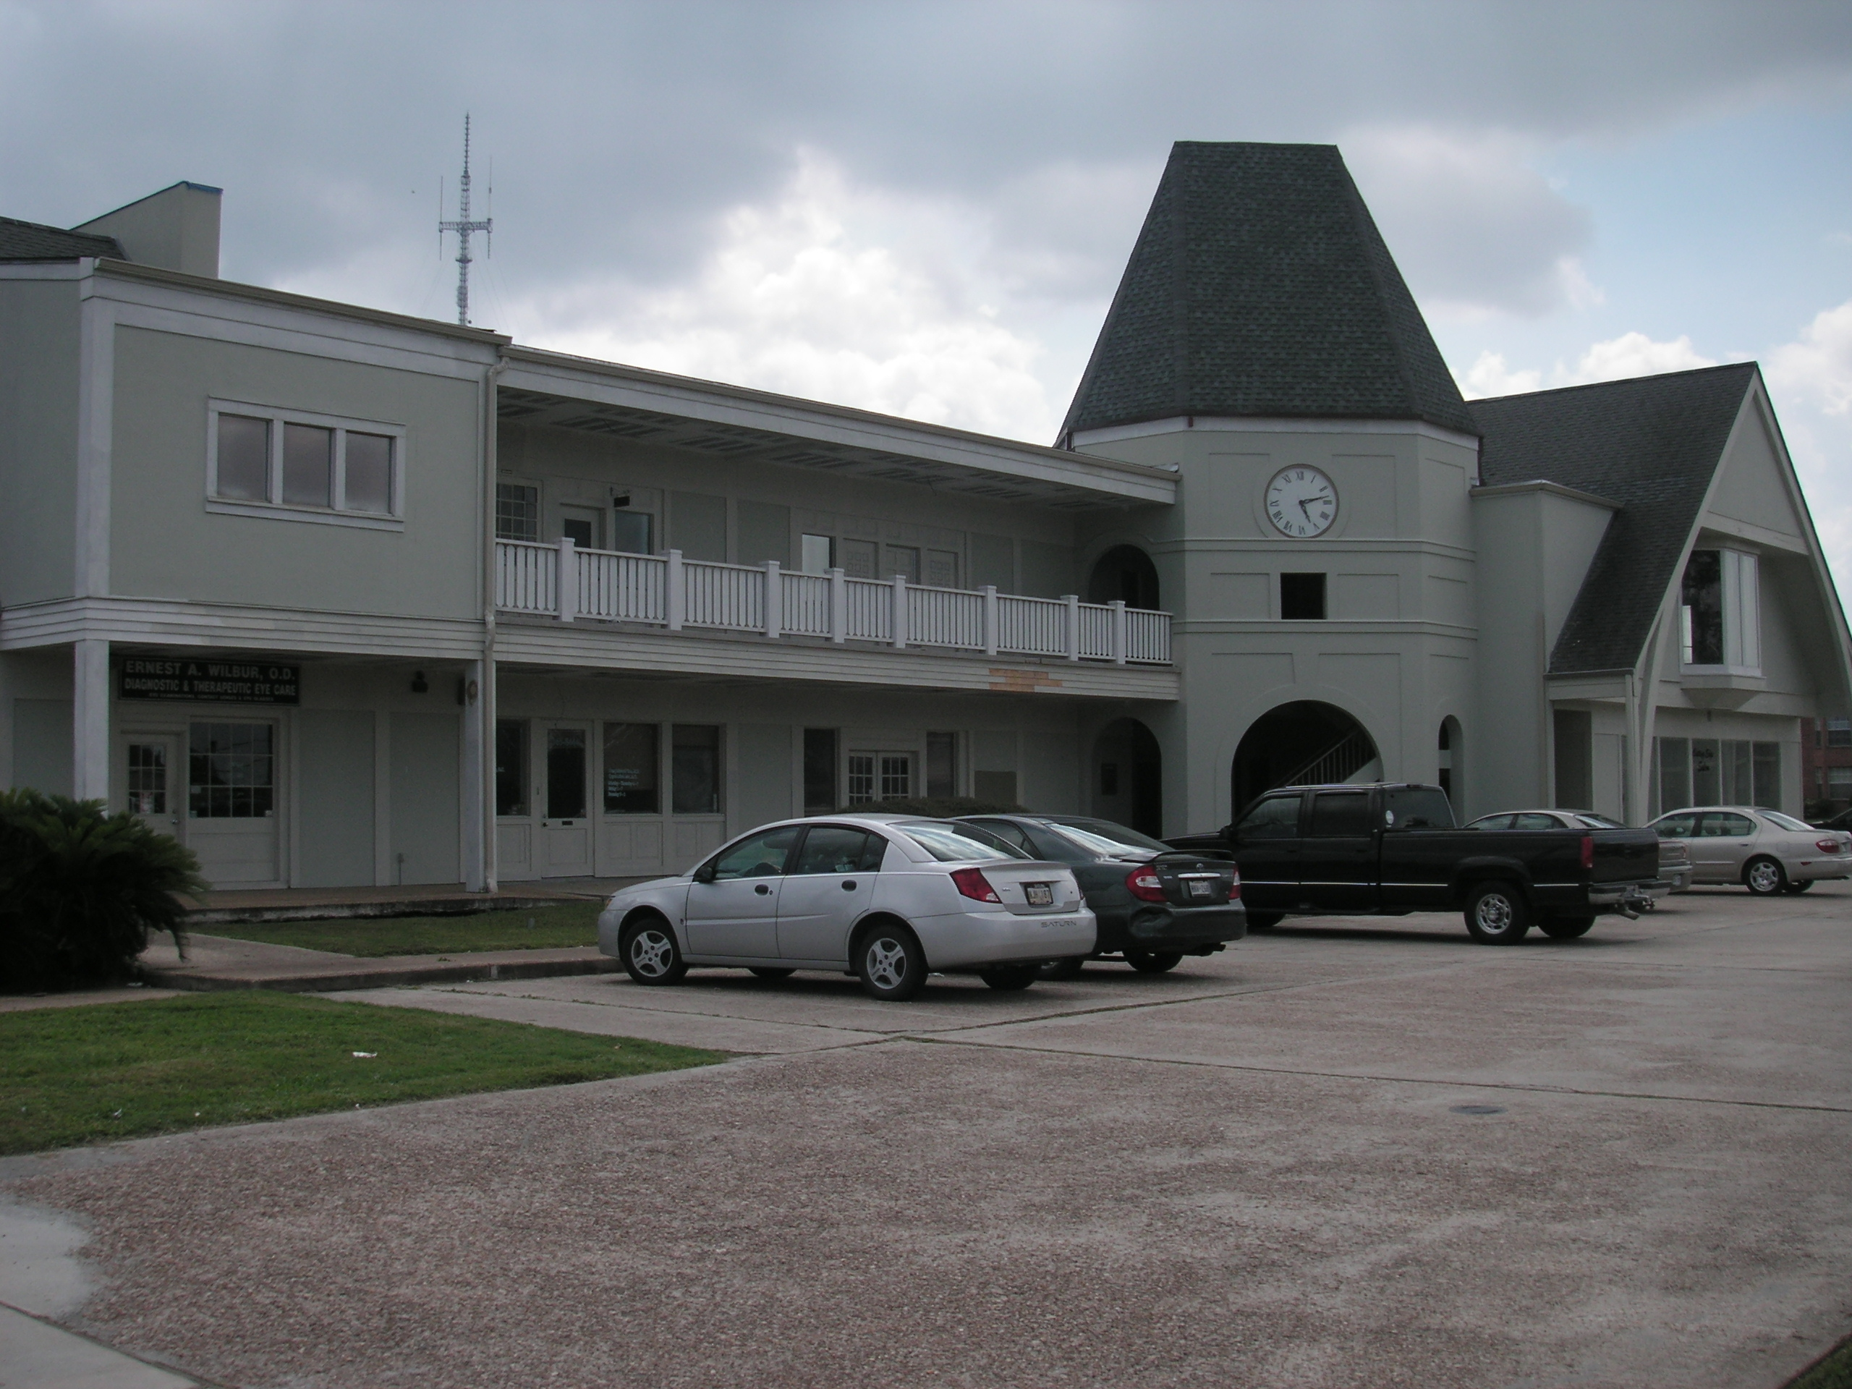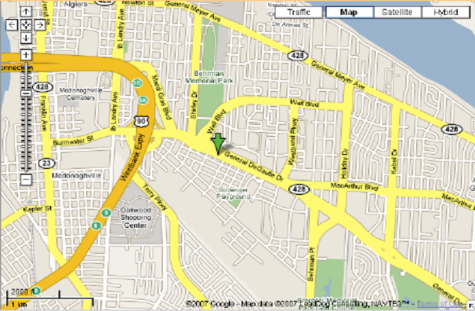

2901 General DeGaulle Drive, Suite 200, New Orleans, LA 70114

Building: 14,114 Sq Ft Construction: Stucco

Office: 7,053 Sq Ft Parking: front and back

Lease Price: $4,796.04 per mo. NET ($8.16 psf)

2020 Taxes: $9,569.82 – ($797.49 per mo.) $1.36 psf

2020-21 Insurance: $7,081.99 – ($590.17 per mo.) $1.00 psf

2019 CAM: $10,103.24 – ($841.94 per mo.) $1.43 psf

TOTAL PER MO. $7,025.64

Further Information: Randall Walker, SIOR
The Industrial Group
1504 L & A Road
Metairie, LA 70001
(504) 832-8012
Randall@igreal.com
Licensed By the Louisiana & Mississippi Real Estate Commissions
Licensed By The Louisiana State Licensing Board of Contractors.




